Project Report
on
Heart Attack Prediction

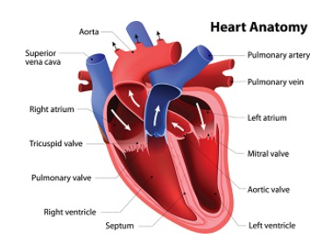

Name: Anmol Rattan
Mobile Number: +91-8375973234
E-mail ID: anmolr43@gmail.com
Batch: Fidelity International – Data Analytics Training (CIDAP 22-07-06)

Table of Contents

- GitHubURL............................................................................................................................................................3
- Abstract................................................................................................................................................................3
- Introduction..........................................................................................................................................................3
- Dataset..................................................................................................................................................................4
- Implementation Process.......................................................................................................................................5
- Results.................................................................................................................................................................11
- Insights................................................................................................................................................................12
- Appendix.............................................................................................................................................................13

Project Report GitHub URL

https://github.com/Anmolra88/UCDPA_AnmolRattan

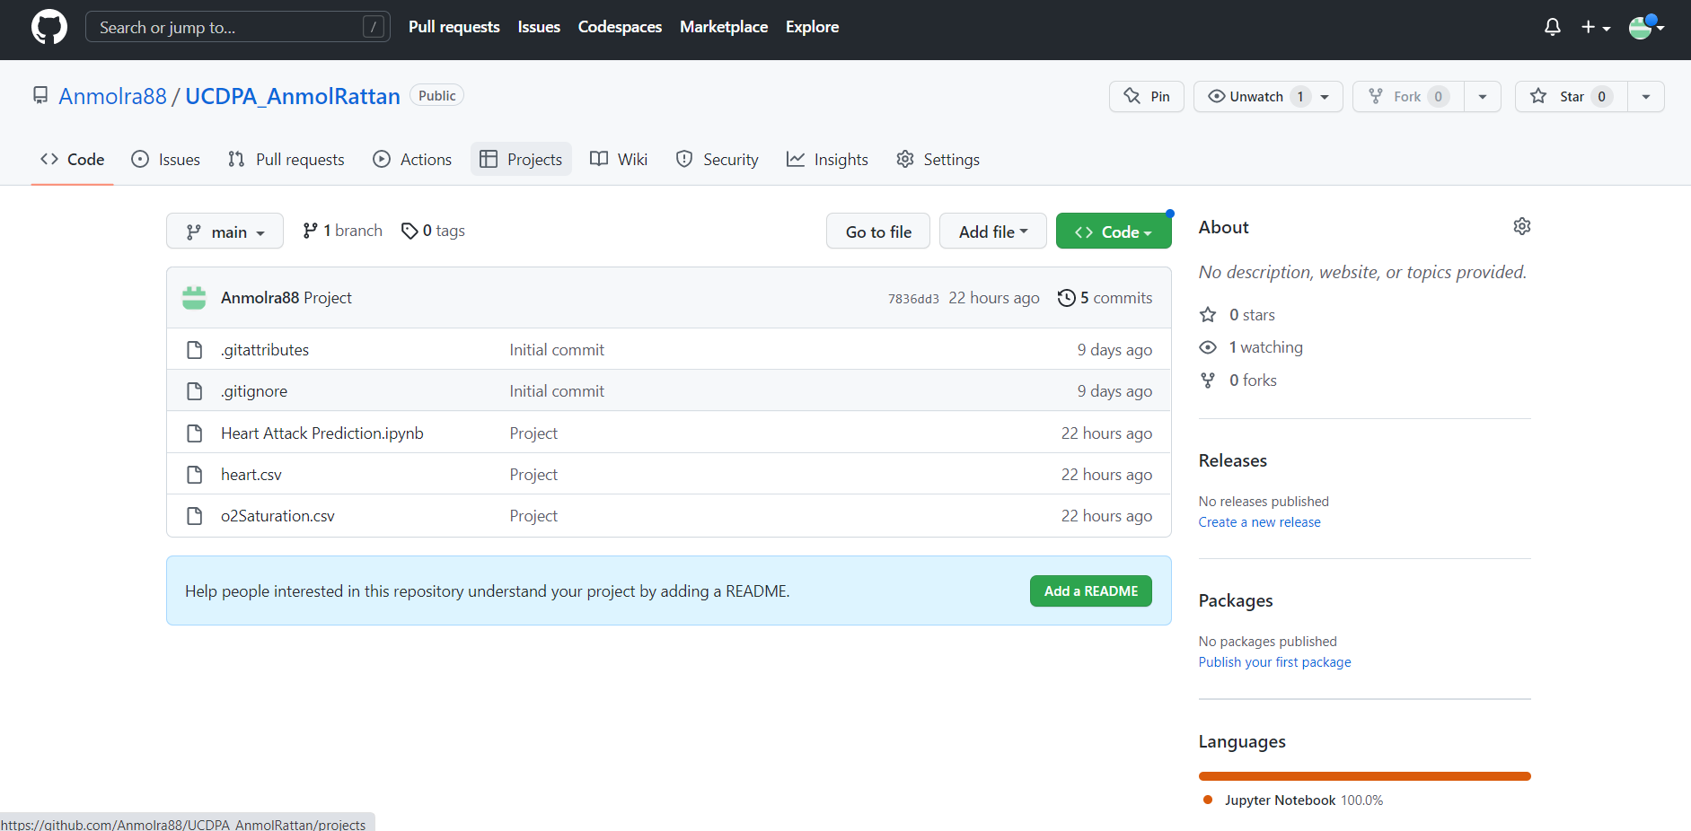

Abstract

The case study pertains to healthcare wherein the task is to estimate the probability of having a Heart Attack using the data set based on the multiple factors such as high blood pressure, blood sugar imbalance, any other medical conditions and age. The data has been collected across different age groups and gender to get a precise output.

In a nutshell, the major aim of this project is to predict patients who might have higher risk of having a Heart attack.

Introduction

A heart attack is a medical emergency that occurs when blood supply to part of the heart is suddenly cut off. A heart attack is a medical emergency that occurs when blood supply to part of the heart is suddenly cut off.
The heart muscles are supplied by the coronary arteries, which branch off from a major artery called the aorta. Heart attack occurs when one or more of the coronary arteries becomes blocked. This lack of blood supply and oxygen can cause injury to the heart muscle and if supply is prevented for more than 20 minutes, the part of the muscle tissue failing to receive blood may die. The medical term for a heart attack is myocardial infarction or MI.
I chose this project because in India alone, the heart attack percentage in Rural and Urban India is 7.4% and 13.2% respectively and the same is rising YoY. The model would help the individual to help predict the chances of having a heart attack.

Dataset

I have taken a real-world data and this dataset contains information about diagnoses of heart disease patients. Machine learning model is needed in order to determine whether a person has heart disease or not.

Variable Name | Description | Sample Data
Age | Patient Age  (in years) | 63; 37; ...
Sex | Gender of patient  (0 = male; 1 = female) | 1; 0; ...
cp | Chest pain type  (4 values: 0, 1, 2, 3) | 3; 1; 2; ...
trestbps | resting blood pressure  (in mm Hg) | 145; 130; ...
chol | Serum cholesterol  (in mg/dl) | 233; 250; ...
fbs | Fasting blood sugar > 120 mg/dl  (1 = true; 0 = false) | 1; 0; ...
restecg | Resting electrocardiographic results  (values 0, 1, 2) | 0; 1; ...
thalach | Maximum heart rate achieved | 150; 187; ...
exang | Exercise induced angina  (1 = yes; 0 = no) | 1; 0; ...
oldpeak | ST depression induced by exercise relative to rest | 2.3; 3.5; ...
slope | The slope of the peak exercise ST segment  (values 0, 1, 2) | 0; 2; ...
ca | number of major vessels (0-4) coloured by fluoroscopy | 0; 3; ...
thal | (3 = normal; 6 = fixed defect; 7 = reversable defect) | 1; 3; ...
Target | Target column  (1 = Yes; 0 = No) | 1; 0; ...

Implementation Process

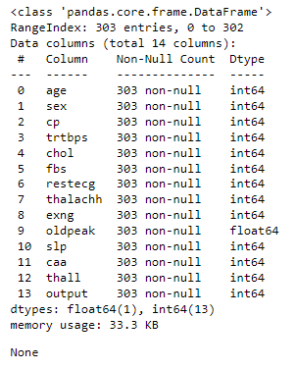

The dataset has been successfully imported.

In the dataset, there are 14 columns with 303 observations. Also, there are no null values and the details of each variable can be seen above.

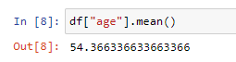
The mean age of the patient is 54.4

Following is the distribution of Data:

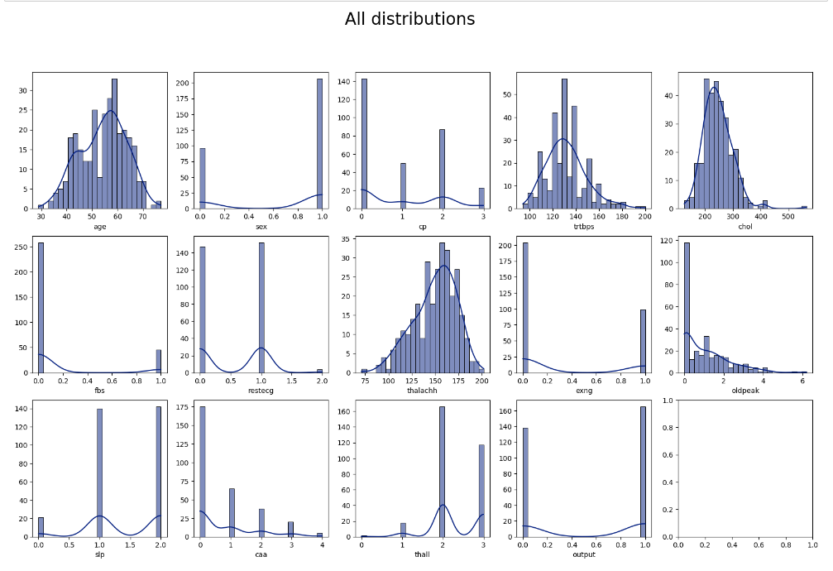

The data interpretation based on the above distribution is as below:

Sex: The distribution of male patients is highest compared to female patients.
CP: Chest pain type 0 have the highest number compared to other types of chest pain.
FBC (Fasting Blood Sugar): It can be seen that the number of patients with fasting blood sugar less than 120 mg/dl have the highest numbers.
restecg (Resting Electrocardiographic Results): Resting electrocardiographic with results 1 and 0 has a higher distribution than result 2. In addition, result 1 has the highest distribution compared to the other results.
exang (Exercise Induced Angina): Patients with no exercise induced angina are the highest compared to patients with exercise induced angina.
slope (Slope of the Peak Exercise): The distribution of slope 1 and 2 are almost the same.
Moreover, slope 2 has the highest distribution compared to others.
ca (Number of Major Vessels): People with 0 major vessel has the highest distribution compared to others.
Thal: Patients with 2 "thal" has the highest distribution compared to others.
target (Heart Diseases Status): The total number of patients that have heart diseases are higher than patients that have no heart diseases.

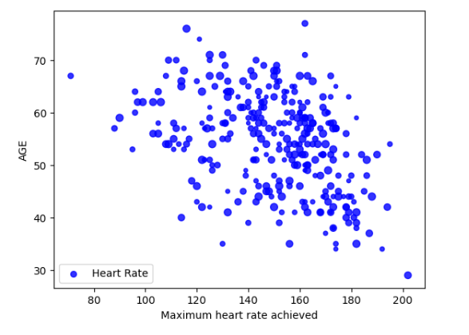
Based on age, patients with and without heart diseases mostly between 50-70 years old.

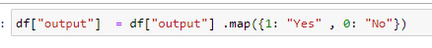
I have changed the output variable for a better representation:
- 1 being stated as “Yes” and have a high risk of Heart Attack
- 0 being stated as “No” and have a low risk of Heart Attack

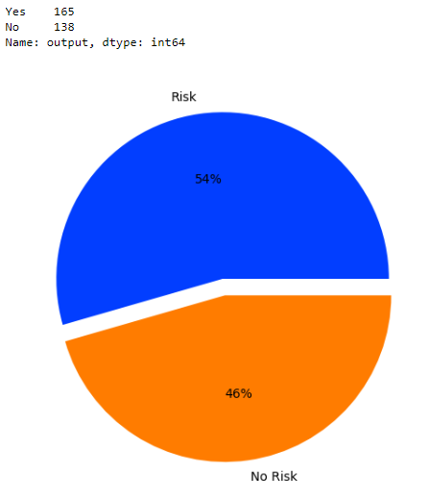

Finding the correlation between the categorical values is as below:
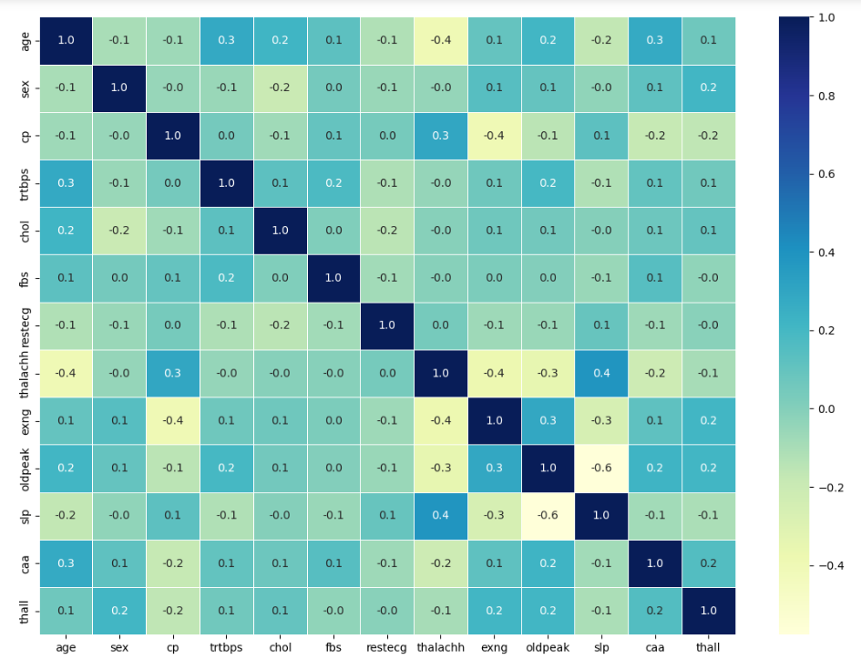

Resting blood pressure, cholestoral, and "oldpeak" have moderate relationship with age.

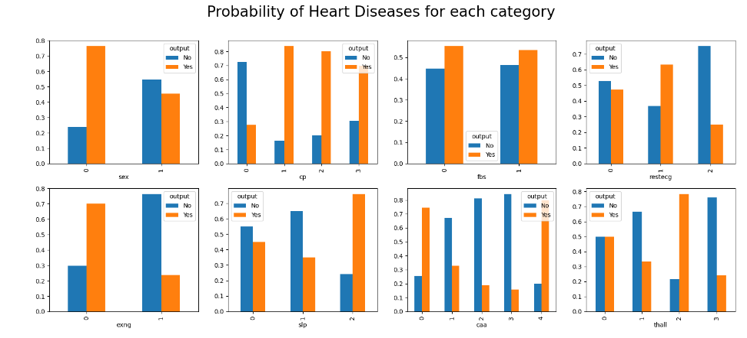

- Women are more likely to have heart problem than men (based on ratio)
- Typical angina has lower chance of heart attack than other chest pains
- People with lower major vessels (caa) have much higher chance of heart attack
- People with Thall == 2 have much higher chance of heart attack
- Slope has positive relation with heart attack and People with Slope = 2 have much higher chance of heart attack

Splitting the Dataset

After analysing the data I have split the same into 80:20 ratio (80% training and 20% testing):

Model Algorithm Selection

I have run the data on multiple models to test the model with the most accuracy.

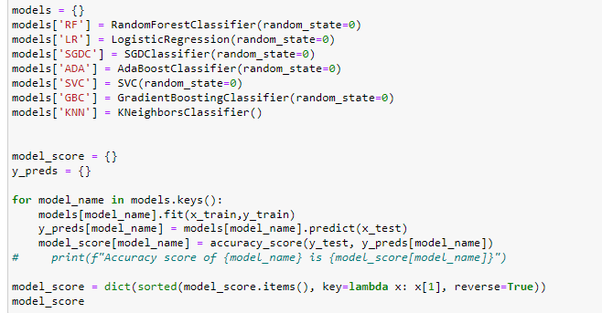
Following is the output of different models’ accuracy scores:

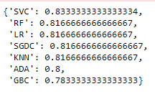

It can be clearly seen that the accuracy score for the top 3 models is as below:

Support Vector Machine (SVM) - 0.83
Random Forest Classifier Model - 0.81
K-Nearest Neighbour – 0.81

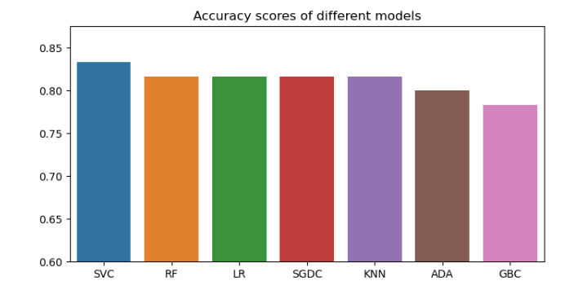

Support Vector Machine (SVM): It is one of the most popular Supervised Learning algorithms, which is used for Classification as well as Regression problems.
The goal of the SVM algorithm is to create the best line or decision boundary that can segregate n-dimensional space into classes so that we can easily put the new data point in the correct category in the future. This best decision boundary is called a hyperplane.
SVM chooses the extreme points/vectors that help in creating the hyperplane. These extreme cases are called as support vectors, and hence algorithm is termed as Support Vector Machine

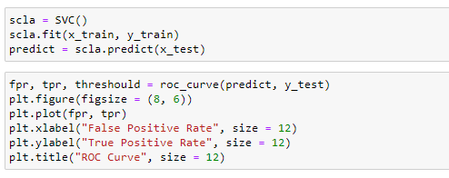

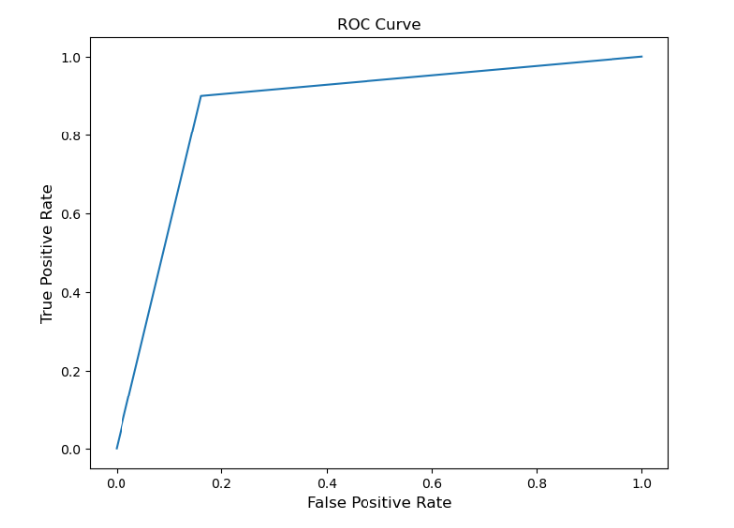

Random Forest Classifier Model: Random Forest is a popular machine learning algorithm that belongs to the supervised learning technique. It can be used for both Classification and Regression problems in ML. It is based on the concept of ensemble learning, which is a process of combining multiple classifiers to solve a complex problem and to improve the performance of the model.

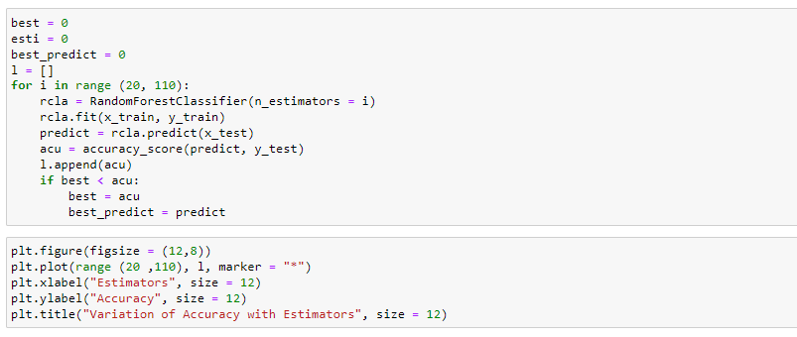

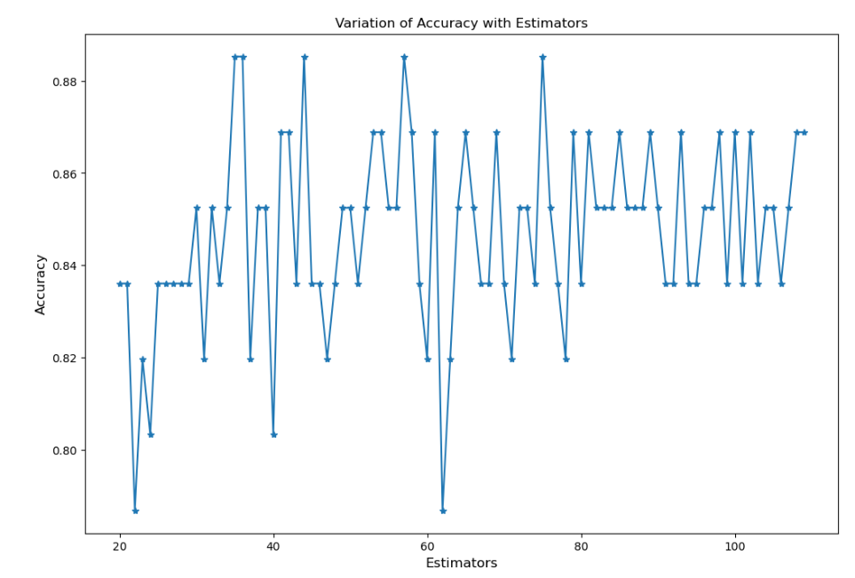

K-Nearest Neighbour: The k-nearest neighbours (KNN) algorithm is a data classification method for estimating the likelihood that a data point will become a member of one group or another based on what group the data points nearest to it belong to. The k-nearest neighbour algorithm is a type of supervised machine learning algorithm used to solve classification and regression problems. It's called a lazy learning algorithm or lazy learner because it doesn't perform any training when you supply the training data. Instead, it just stores the data during the training time and doesn't perform any calculations. It doesn't build a model until a query is performed on the dataset. This makes KNN ideal for data mining.

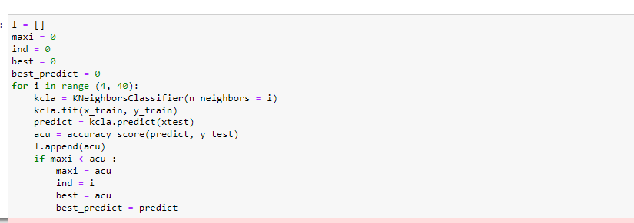

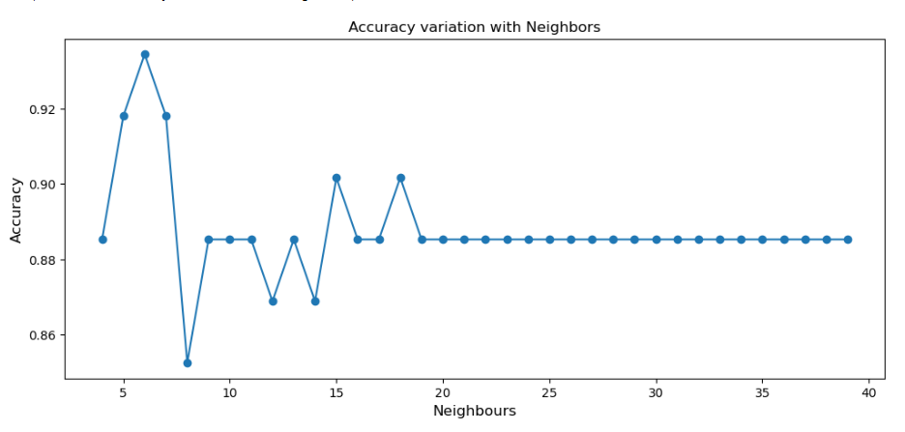

Results

The analysis was run on 3 model sets to get the maximum accuracy for the test dataset.

The top results were received from Support Vector Machine (SVM) resulting in 83% accuracy. The model helps in identifying the probability of heart attack and based on the output it helps provide the most suitable and accurate medication to the patient.

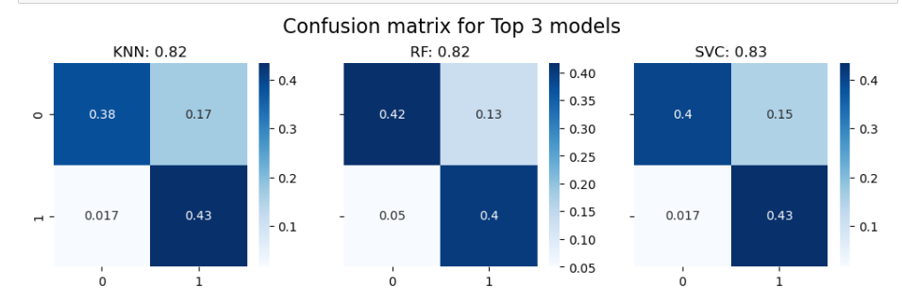

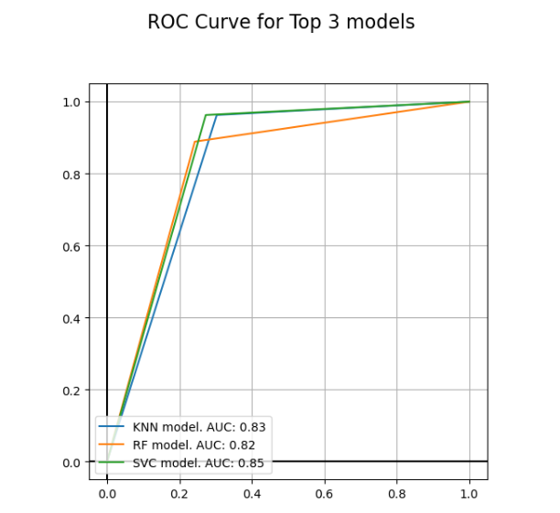

Insights

- As we look at the ROC curve chart, SVC has maximum area under curve and is most accurate for use on this dataset.
- KNN is the 2nd best model that can be used for this dataset.
- The confusion matrix helps us understand that in our final selected model, False positive cases are not that much high i.e. ~0.017 , which is a good sign.
- Women are more likely to have heart problem than men (based on ratio)
- Middle aged (45 to 60 years) persons have higher chance of heart attack
- People with Maximum Heart Rate Achieved > 150 has higher chance of heart attack
- Chest Pain has higher chance of heart attack
- Typical angina has lower chance of heart attack than other chest pains
- People with lower major vessels (caa) have much higher chance of heart attack
- Age has positive relation with n major vessels (caa) (older people are more likely to have vessels)
- People with Thall == 2 have much higher chance of heart attack
- Slope has positive relation with heart attack and People with Slope=2 have much higher chance of heart attack
- trtbps (Resting Blood Pressure) has positive relation with Age
- oldpeak (ST depression induced by exercise relative to rest) has highly negative relation with heart attack

References

https://www.kaggle.com/
https://www.w3schools.com/
https://github.com/

Appendix

Some additional functions which I have practiced separately and not as a part of project, the working for these functions is in Additional Functions.ipynb:

- re.findall :

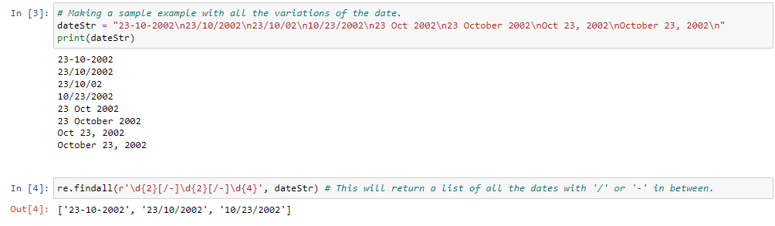

- Labelling data fields to Text value for easy interpretation of Visualization:

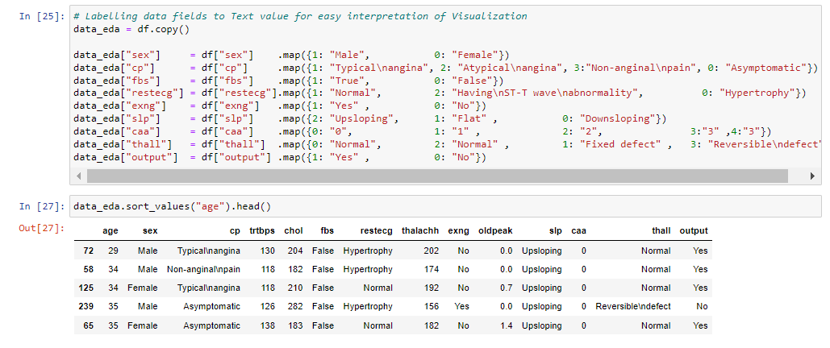

- API Web Scraping:
